Tasks To Be Performed:

1. Use the template from CloudFormation task 1.

2. Add Notification to the CloudFormation stack using SNS so that you get a notification via mail for every step of the stack creation process

Use the template from CloudFormation task 1.

Parameters:

  BucketNameParameter:

    Type : String

    Description: 'give a bucket name'

Resources:

  S3Bucket:

    Type: 'AWS::S3::Bucket'

    Properties:

      BucketName: !Ref BucketNameParameter

      VersioningConfiguration:

        Status: Enabled

* Go to CloudFormation > Create stack
* Prepare template> Choose an existing template
* Specify template > Upload a template file
* Upload a template file > upload ymal file
* Stack name > demos3
* Parameters > Bucket Name Parameter > Intellipaat-karthik
* Advanced options
* > Notification options – optional
* > Create new SNS topic
* > SNS topic name (S3stacknotifaction)
* > Email address (karthikmsd797@gmail.com)
* Next > Review and create

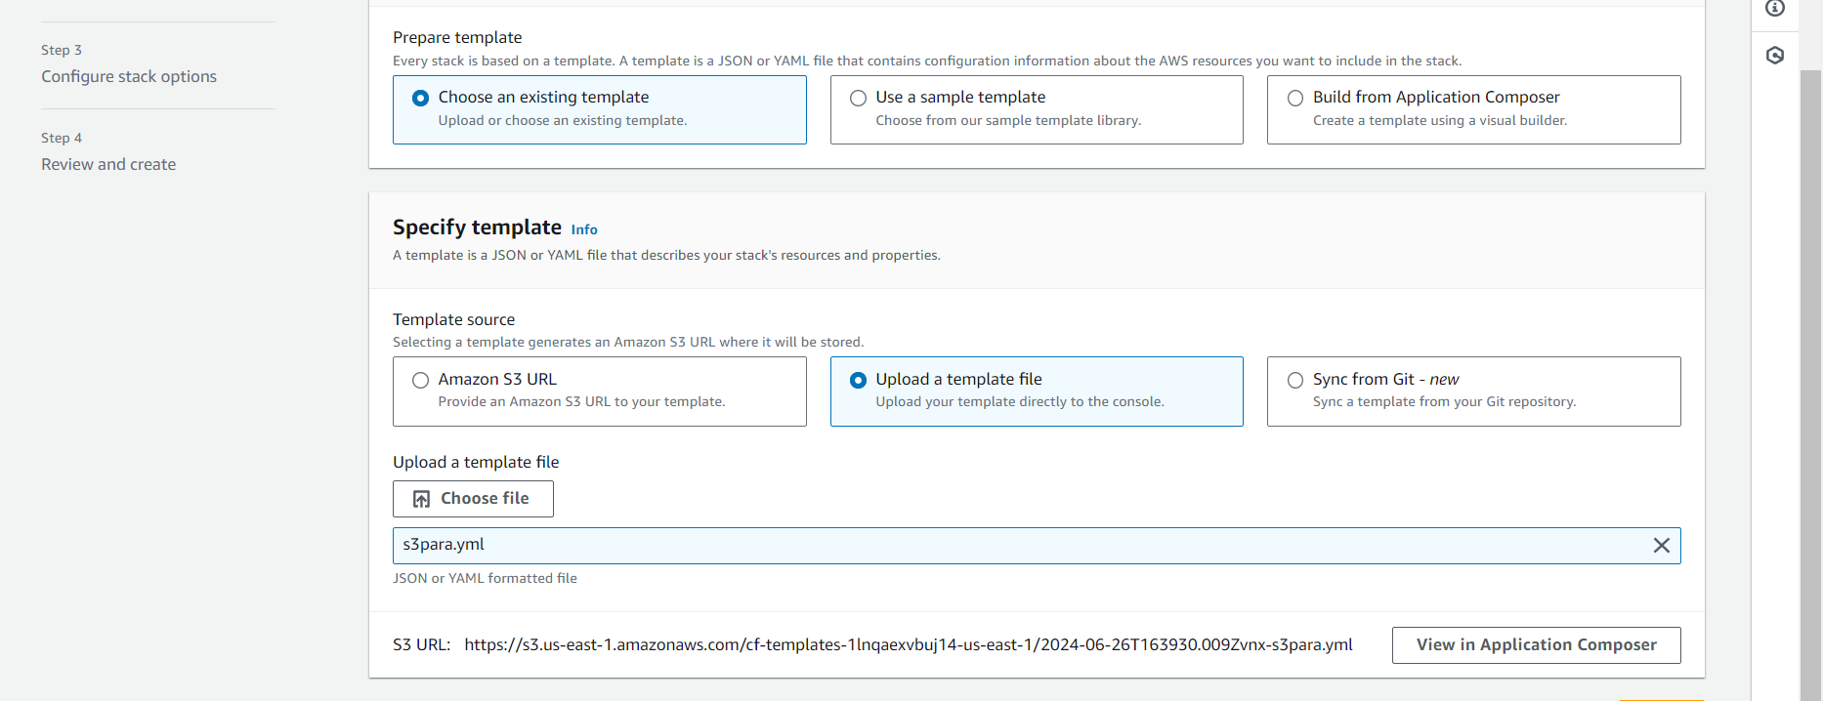

Add Notification to the CloudFormation stack using SNS so that you get a notification via mail for every step of the stack creation process

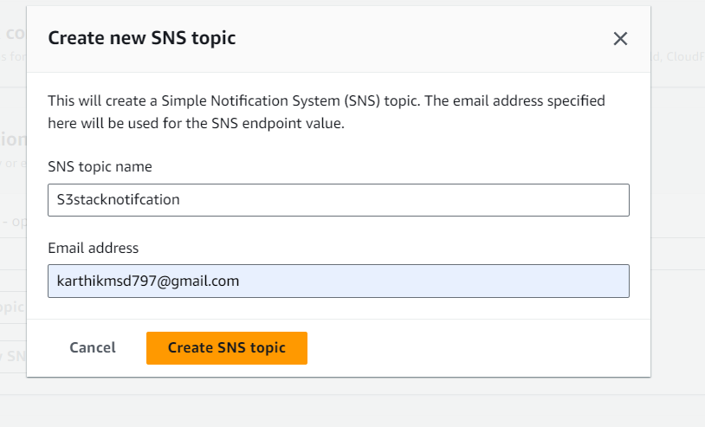

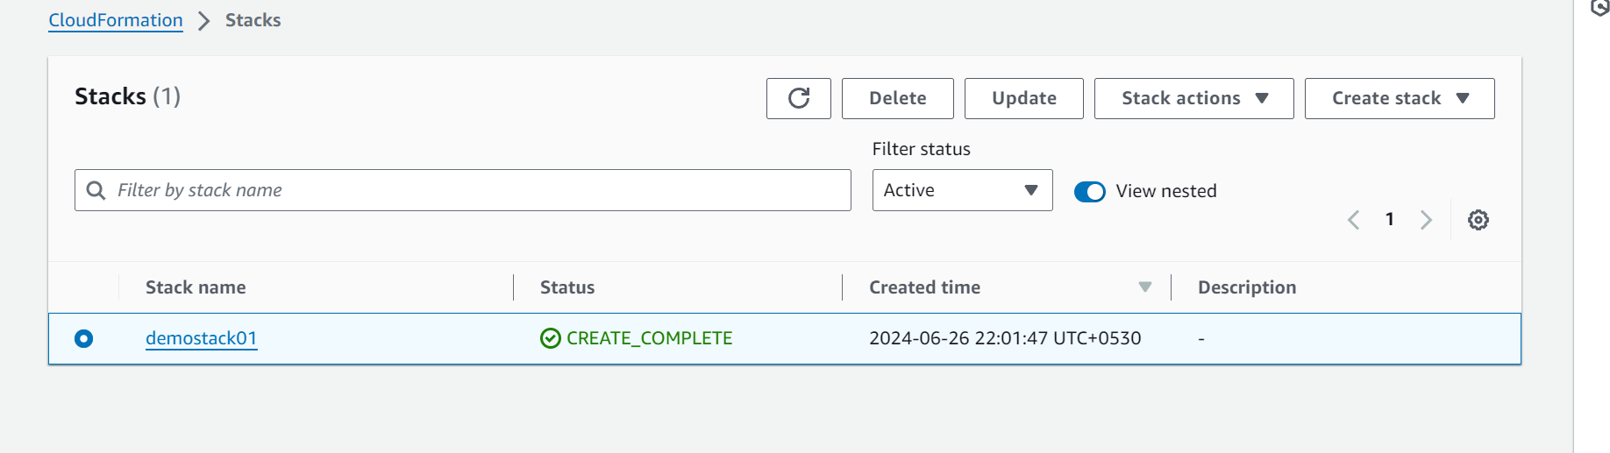

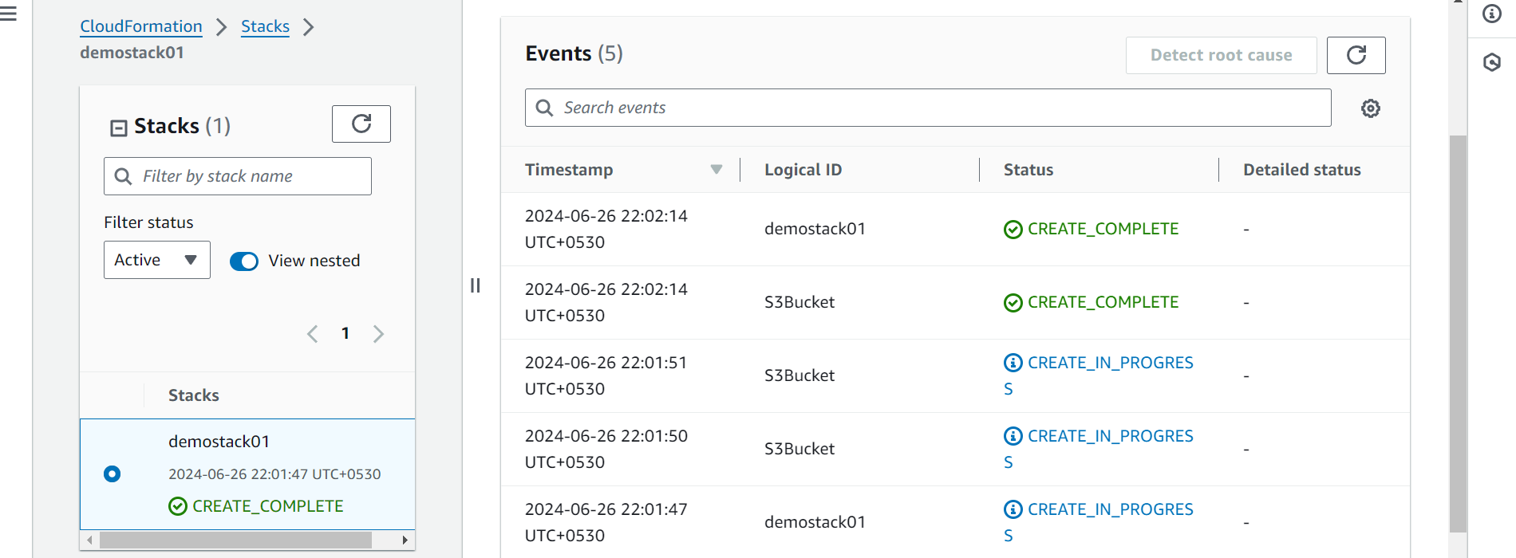

Each stack creation step notification received.

